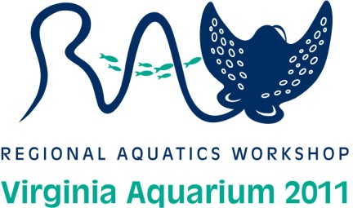
RAW 2011 SPONSORSHIP COMMITMENT FORM

Name of Company:______________________________________________________

Contact Name:__________________________________________________________

Email:_________________________________________________________________

Phone:________________________________Fax:_____________________________

Address:_______________________________________________________________

Sponsorship Level Selection (check all that apply)

Platinum Sponsorship____________________________________ $2,500

Gold Sponsorship________________________________________ $2,000

Silver Sponsorship________________________________________$1,000

Bronze Sponsorship_______________________________________$500

Event Sponsorship__________________________Contact Host for Price
- Breaks in General Sessions ( # of breaks___________)
- Break during Focus Session (AM)
- Break during Focus Session (PM)
- RAW First-Timer Mixer Event (May 2)
- Hospitality Suite Evening Sponsor (May 3-5)
- Ice Breaker Event at the Virginia Aquarium & Marine Science Center (May 3)
- RAW Coastal Cruise (May 4)
- Aquarist Olympics (May 6- held at Sheraton Oceanfront Hotel)

Please make checks payable to: Virginia Aquarium Foundation
IMPORTANT- Write RAW 2011 on the memo of the check so that funds are properly entered.

To make payment by credit card:
Credit Card (circle one): Visa Mastercard
Print name as it appears on the card:
Credit Card Number:
Expiration Date:
3 Digit Security Code:
Signature:

Please send this form and your donation to:
Virginia Aquarium Foundation- RAW 2011
717 General Booth Boulevard
Virginia Beach, Virginia 23451

